DAY-5 EC2

Task
======
Create a Windows Vm using Microsoft Windows AMI
Allow the https and http traffic in networking section
Connect with the Vm to our windows machine with RDP protocol.

Open AWS Console and login to the Console.
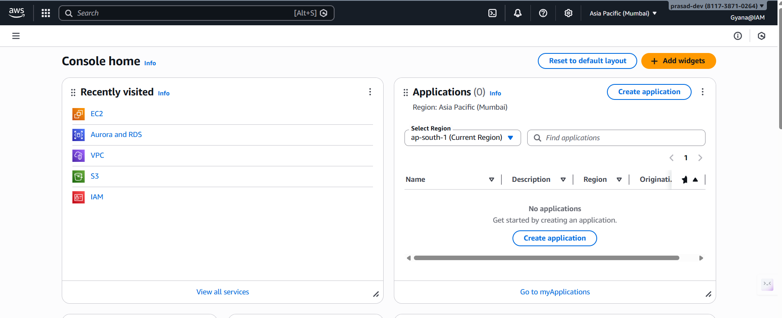
- Go inside the EC2 service and lunch an Instance.
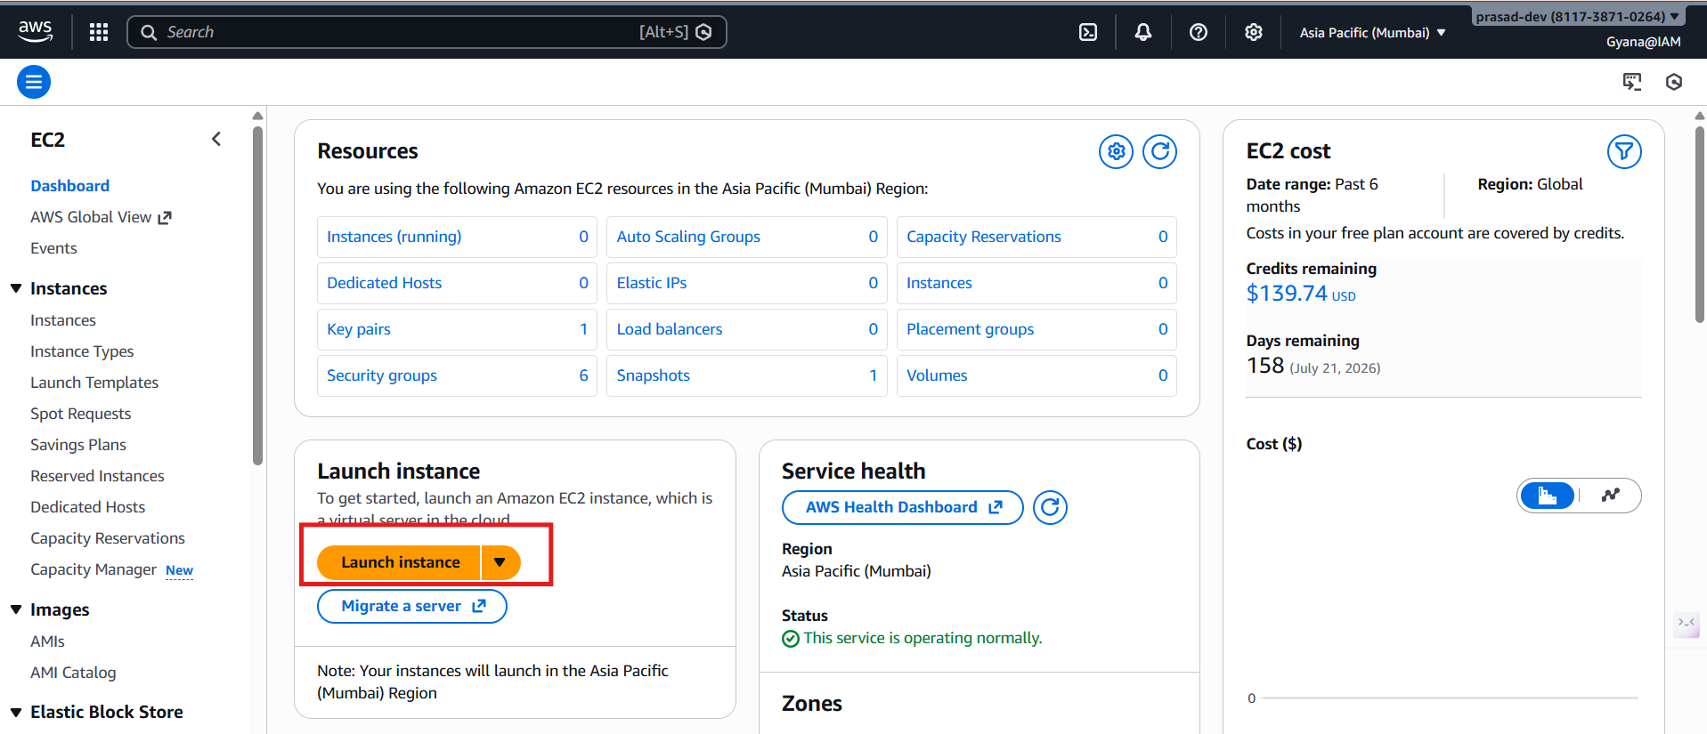

- Creating a virtual machine using the Microsoft Windows AMI.
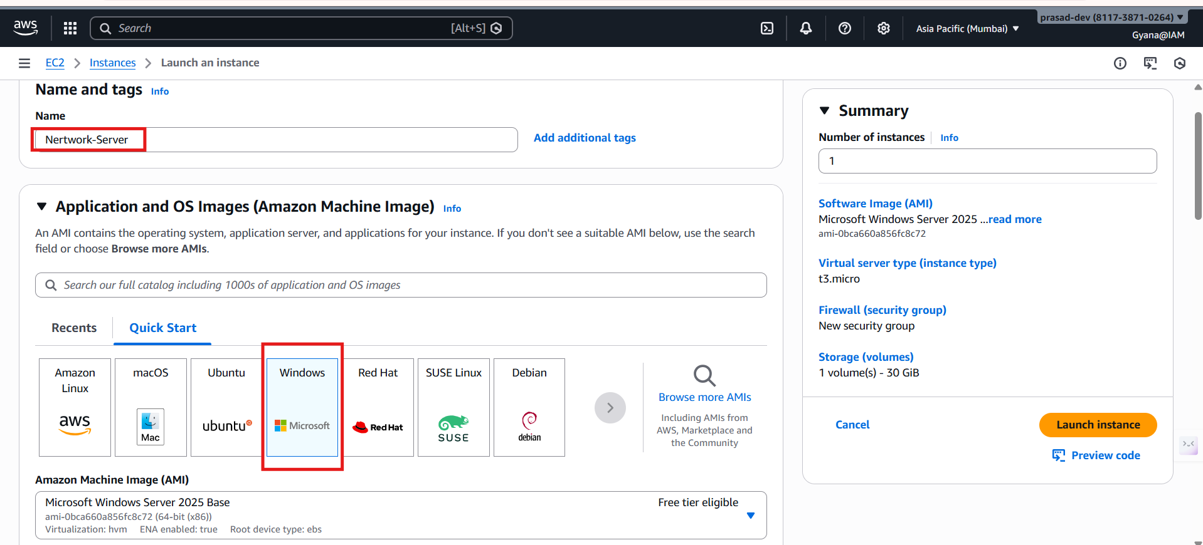
- Using the existing key-pair.
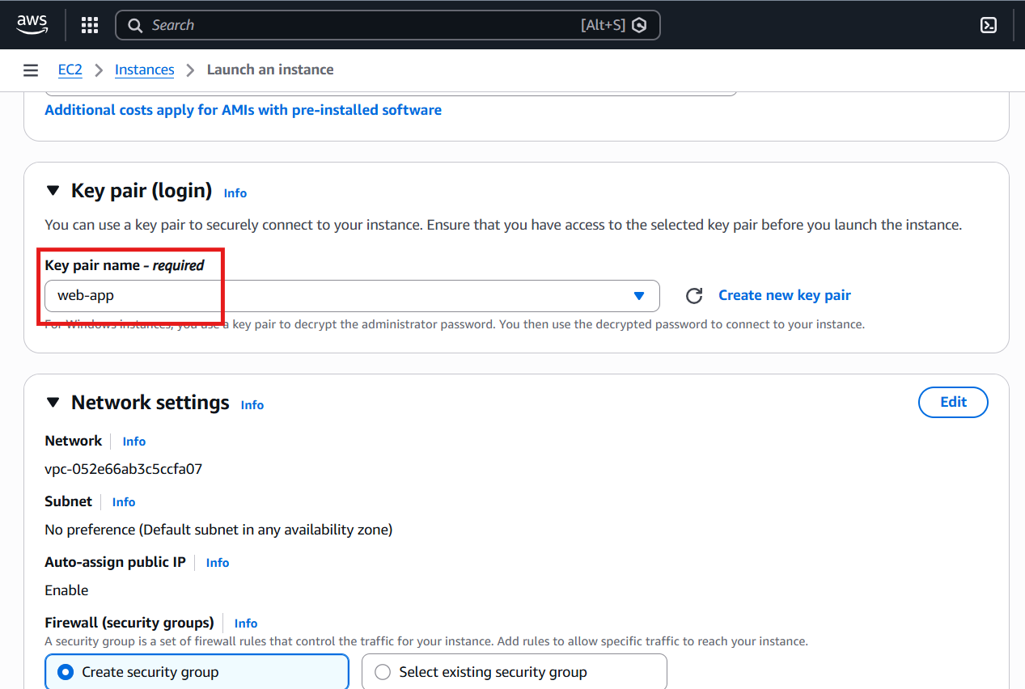

- Allowing the https and http traffic in networking section.
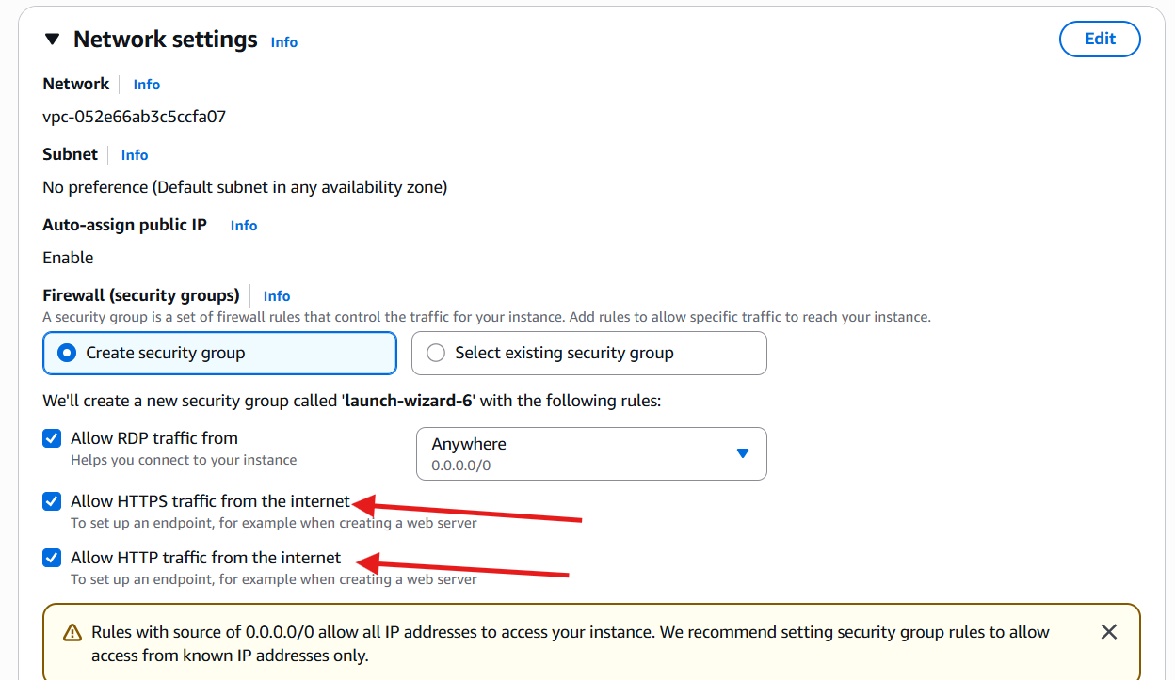
- Check the Default storage for a Windows EC2 Instance is 30gb.
- Now click on Lunch Button to lunch the EC2 instance.
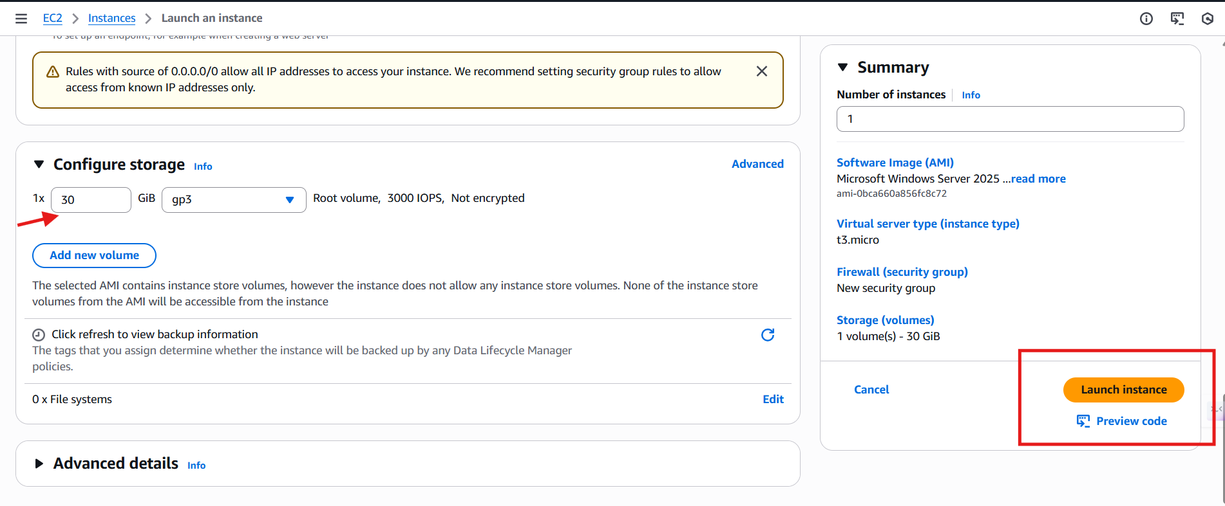
- Instance got Lunched.
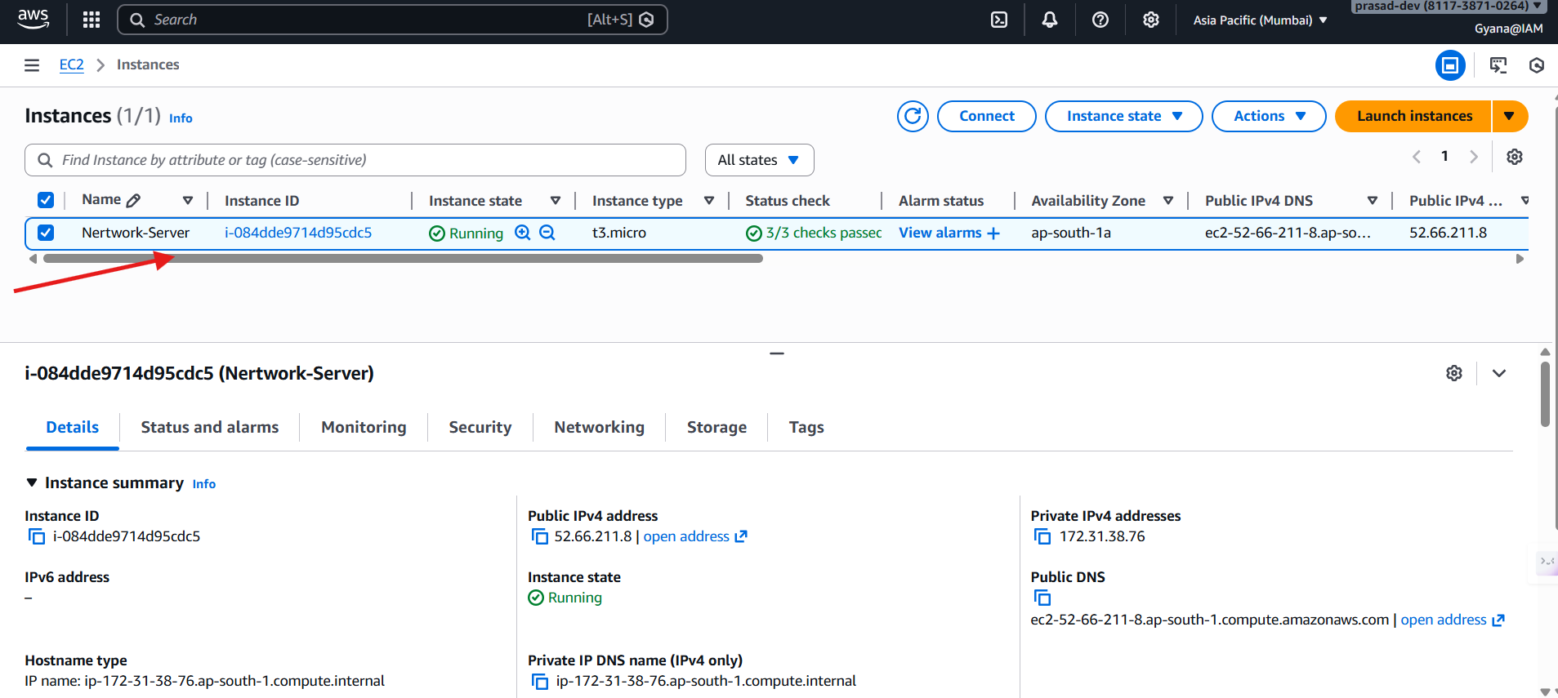
- Now open the Remote Desktop Connection from windows start.
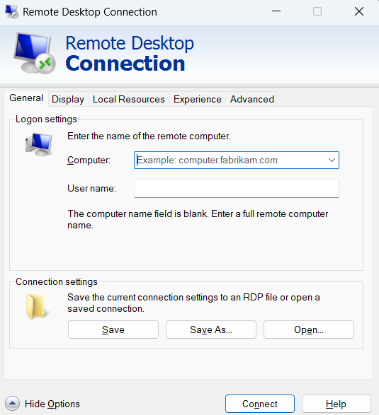
- Enter the Computer name as Public DNS and Username as Administrator but before that click on the Connect button in the by selecting the EC2 Instance.
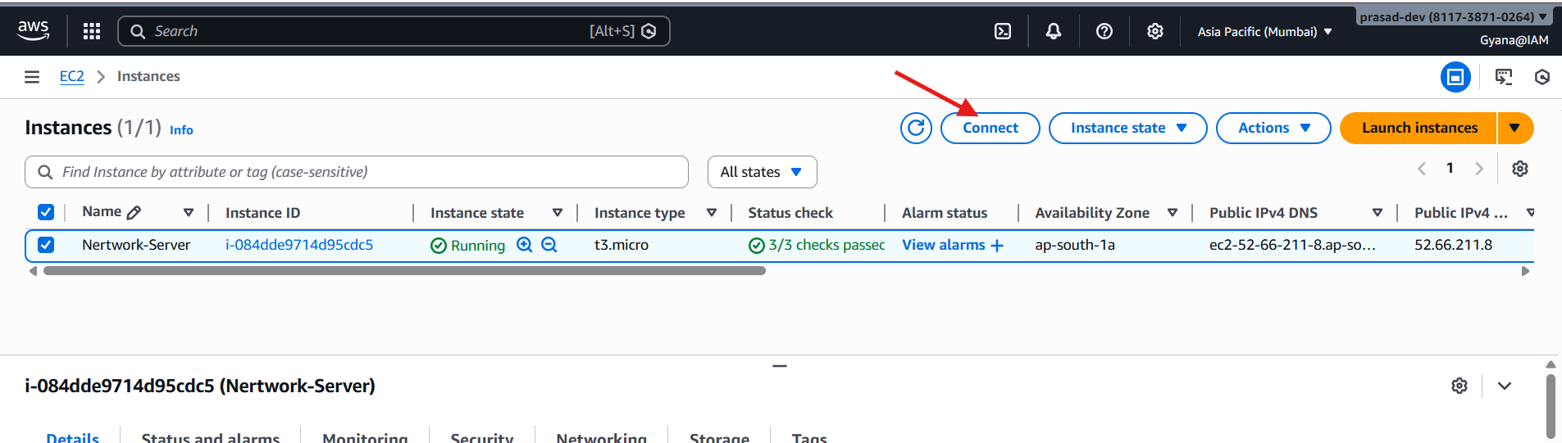
- Now select on that RDP Client option.
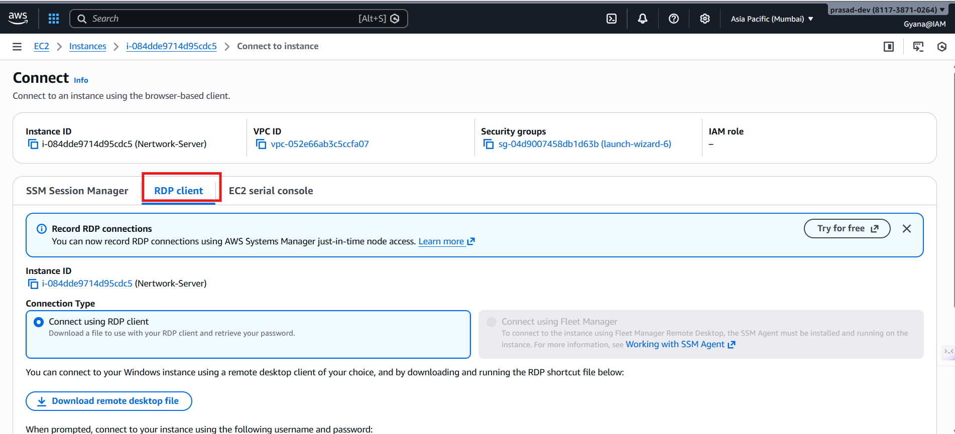
- Scroll down you an see the Public DNS and Username which are noting but the Computer name and Username for the RDC connection.
- But We need a password so for that click on that Get Password option.
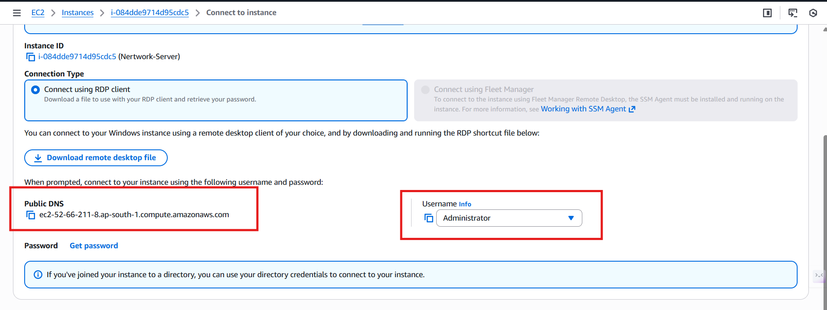

- After clicking on the Get password option click on Upload private key file option and select the downloaded .pem file .
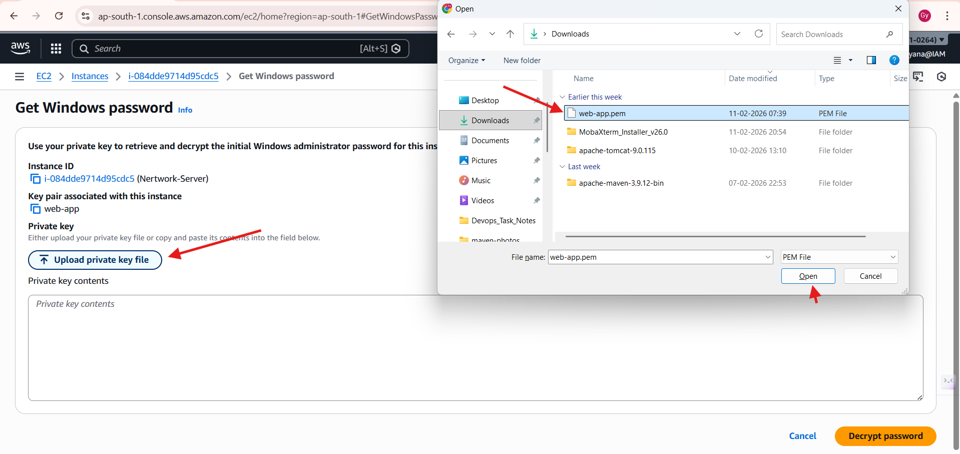
- After uploading CLICK on the DECRYPT PASSWORD button.
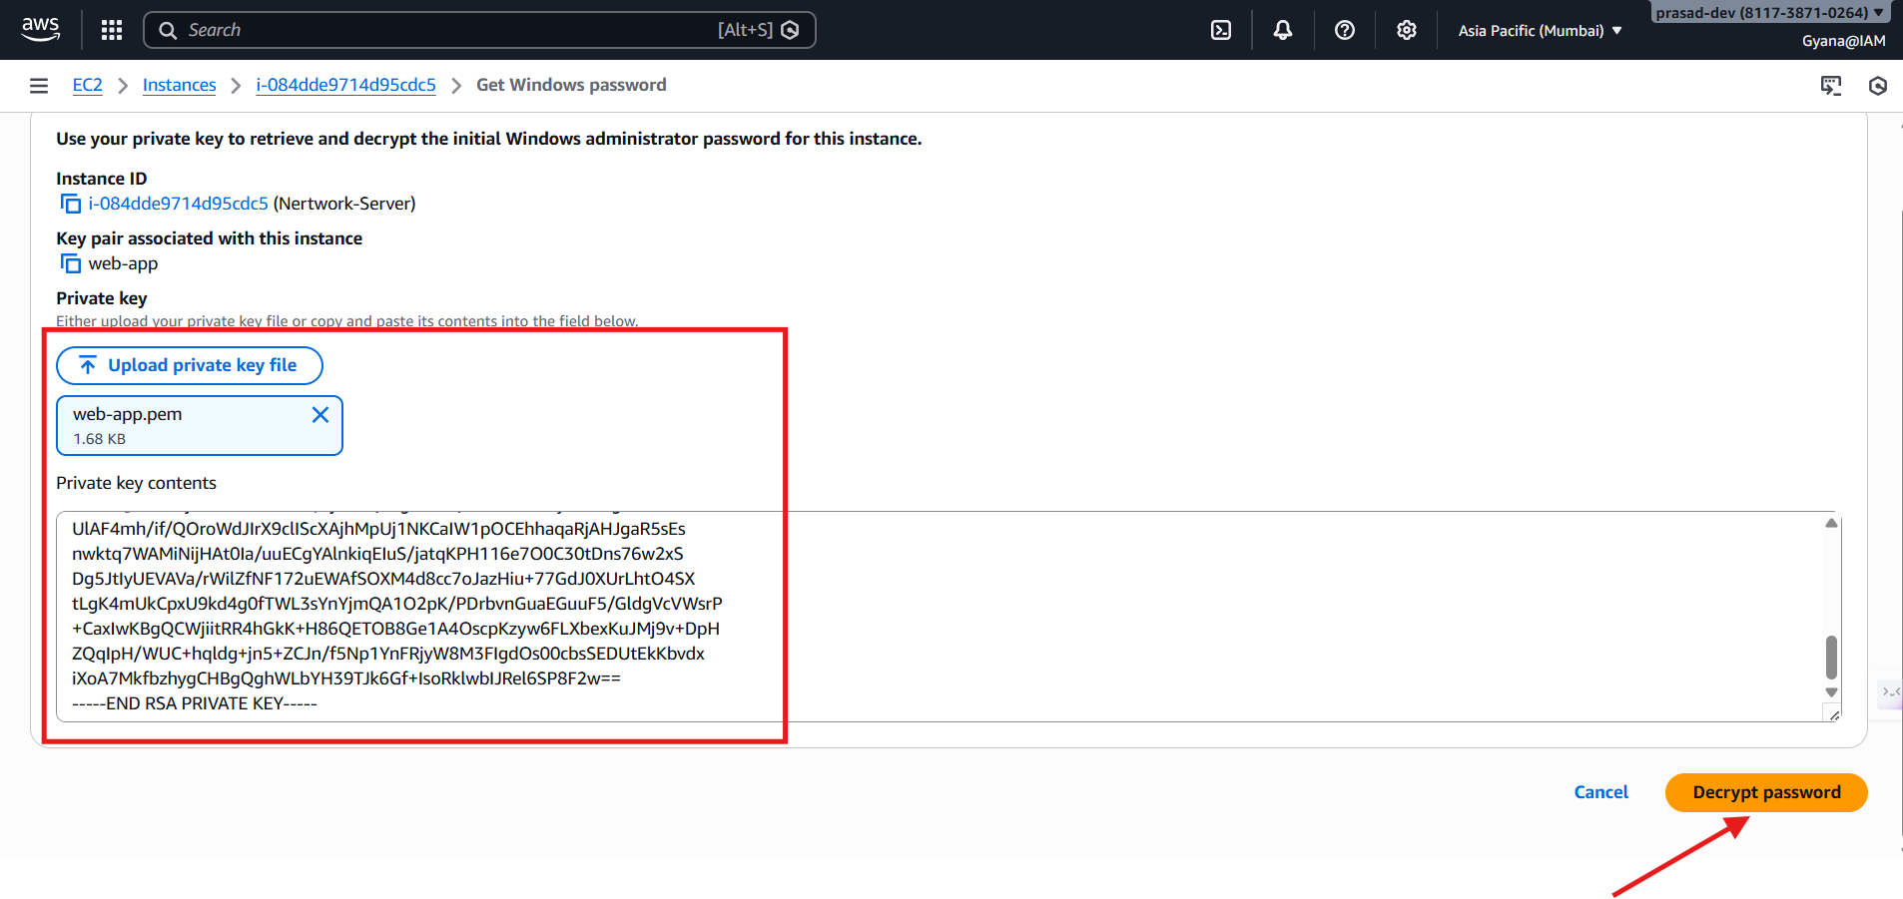
- Now will get the password.
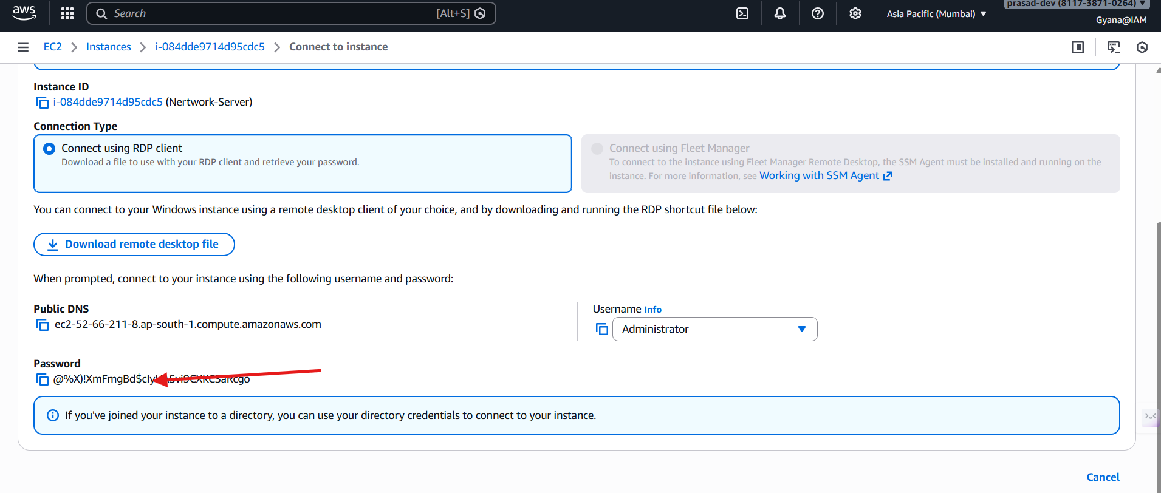
- Now go the Remote Desktop Connect and give all the credential.
- Click connect
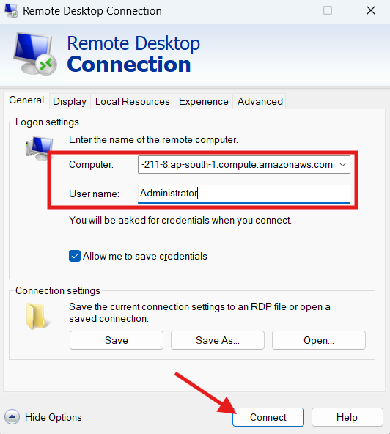

- It will ask for password which is noting but the password we get after decrypting the .pem file copy form the EC2 console and paste it here.
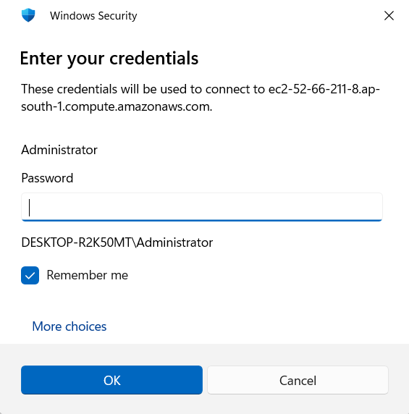
- After entering the password click on Yes it will start the Windows VM.
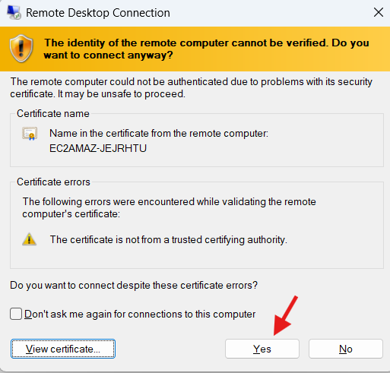

- Windows VM got started.
